## Lab Report – Activity 18: Conserve Energy

## Name ___Li qingfei________________ Date 10.29.2021______

**Student No __57127058___________**

## Prediction (write down your prediction, this will not be counted in the marks of the report)

1. As the ball falls, what will happen to its gravitational potential energy?

The gravitational potential energy will decrease.

1. What will happen to the kinetic energy of the balls as it falls?

The kinetic energy of the balls will increase.

1. How will the change in potential energy compare to the final kinetic energy?

The change in potential energy is equal to the change in final kinetic energy.

## Data

## Print out the graphs of position vs time and velocity vs time and attach them to this report by staples. If there are no labels of the axes, please label the axes. Write down a short title of the graph. (15 marks for each graph, total=30 marks)

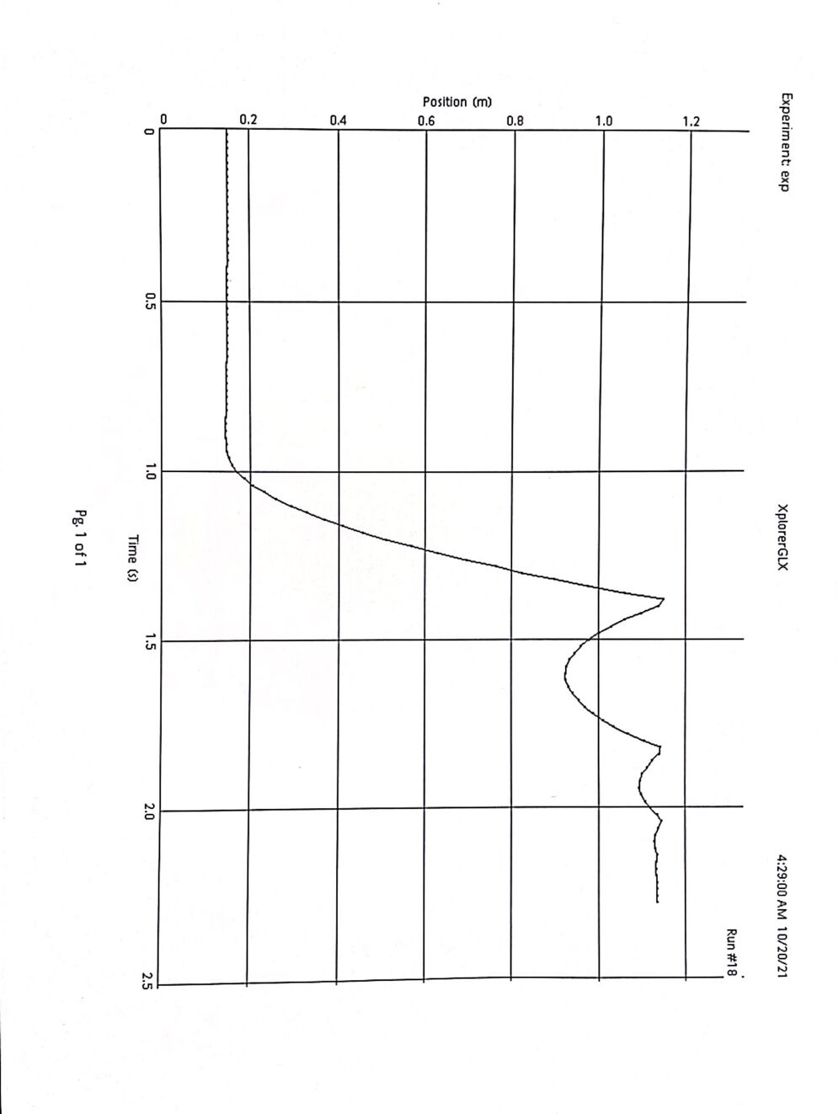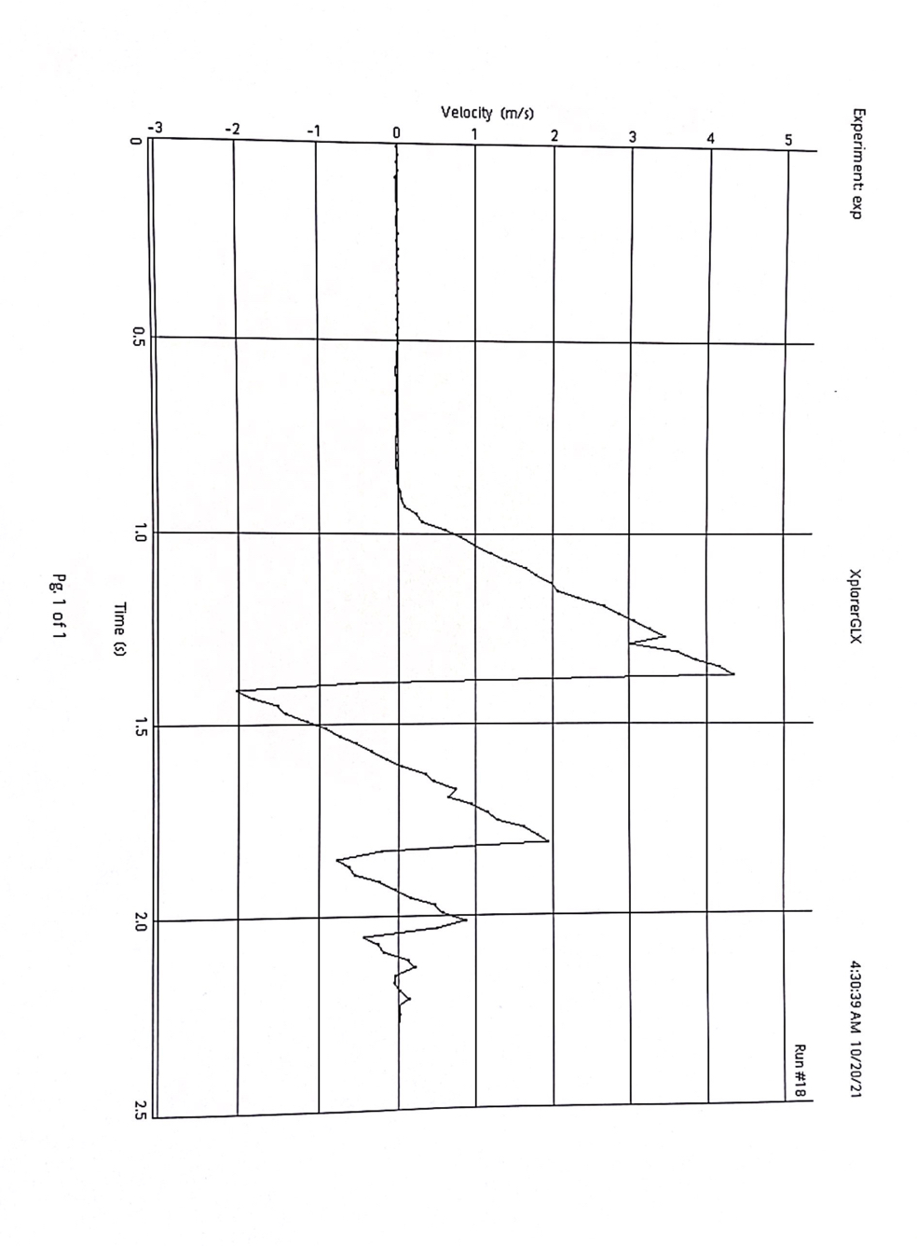

## Fill up the following tables and answer the questions.Data Table (5 marks for each data, total=35 marks)

|  |  |
| --- | --- |
| **Item** | **Value** |
| Mass of ball | 0.5625kg |
| Distance, maximum | 1.147m |
| Time (distance, maximum) | 1.3833s |
| Final velocity | 4.35m/s |
| Change in potential energy | 6.3228J |
| Final kinetic energy | 5.3220J |
| Percent difference | 15.8297% |

### Calculations

Use the mass of the ball and the distance it fell to calculate the change in potential energy. Remember,  where *m* is the mass, *g* is the acceleration due to gravity, and *h* is the height (the distance the ball fell).

Use the mass of the ball and the final velocity to calculate the final kinetic energy. The kinetic energy is where *m* is the mass and *v* is the velocity.

Calculate the percent difference between the change in potential energy and the final kinetic energy. .

### Questions (5 marks for each question, total=20 marks)

1. What happens to the ball’s gravitational energy as the ball falls?

### Gradually smaller

1. What happens to the ball’s kinetic energy as the ball falls?

Gradually grow bigger

1. What is the relationship of kinetic energy and potential energy as the ball falls?

Most of the potential energy transforms to kinetic energy.

1. 4. Do your results support your predictions?

As the elastic deformation occurs, the maximum change of distance we measured is the position when the velocity of the ball is 0. That means that the deformation of the ball is at its maximum. So some of the energy has transformed to elastic potential energy.

So we can conclude that the internal gravity potential energy is equal to the sum of kinetic energy, elastic potential energy and the change of the internal energy caused by the air friction.